CARIAD SE CPM Project

Technical Specification

PR Planning Workbook

|  |  |
| --- | --- |
| Person Responsible: | Daniel Wang, Jiabao Yin, Baobao Gao |
| Status: | in review |
| Version: | V1.0 |
| Date: | 07/05/2025 |
|  |  |
|  |  |
|  |  |

Version History:

| Version | Date | Author | Comments |
| --- | --- | --- | --- |
| V1.0 | 07/05/2025 | Daniel Wang/Jiabao Yin/ Baobao Gao |  |
|  |  |  |  |
|  |  |  |  |

# Technical Architecture

There are two OData services:

* ZCON_PFM_ODATA_PR_PLAN_SRV: Provides PR Plan related business data.
* ZCON_USER_DEFAULT_SRV: This is a shared OData service, providing user default format parameters, including date format and amount format preference.

Tables:

|  |  |
| --- | --- |
| **Table** | **Short Description** |
| ZCON_PFMT_PRPL | PR Level Setting |
| ZCON_PFMT_GROUP | PR Column Setting |
| /RPM/FIN_B_PLAN | Financial planning for Buckets |
| /RPM/CAP_B_PLAN | Capacity planning for Buckets |
| /RPM/FIN_PLAN | Financial Planning for Item |
| /RPM/CAP_PLAN | Capacity planning for Item |

# Front End – Fiori Development

## Initial Screen

The initial page contains 3 dropdowns. Select Portfolio, Initiative and Planning Field to get data.

## Data Query of Initial Screen

### Portfolio

|  |  |  |  |
| --- | --- | --- | --- |
| **Entityset Name** | ZCON_PFM_DDL_I_PORTFOLIO | **HTTP Method** | GET |
| **Return** | | | |
| **Result** | **Code** | **Data** | **Comment** |
| Success | 200 | PortfolioGuid | Portfolio GUID |
| PortfolioName | Portfolio Name |
| PortfolioId | Portfolio ID |
| PortfolioType | Portfolio Type |
| Error | 500 |  |  |

### Initiative

|  |  |  |  |
| --- | --- | --- | --- |
| **Entityset Name** | ZCON_PFM_DDL_I_INITIATIVE | **HTTP Method** | GET |
| **Parameters** | | | |
| **Field** | **Type** | **Description** | |
| PortfolioGuid | String | PortfolioGuid, Serve as Filter. | |
| **Return** | | | |
| **Result** | **Code** | **Data** | **Comment** |
| Success | 200 | PortfolioGuid | Portfolio GUID |
| InitiativeId | Initiative ID |
| InitiativeName | Initiative Name |
| InitiativeType | Initiative Type |
| InitiativeGuid | Initiative GUID |
| Error | 500 |  |  |

### Planning Field

|  |  |  |  |
| --- | --- | --- | --- |
| **Entityset Name** | ZCON_CPM_DDL_I_PLFLD | **HTTP Method** | GET |
| **Return** | | | |
| **Result** | **Code** | **Data** | **Comment** |
| Success | 200 | PlanningField | Planning field ID |
| PlanningField_Text | Planning field name |
| ProfitCenter | Profit center Nr. |
| RequestingCostCenter | Requesting cost center Nr. |
| Error | 500 |  |  |

## Initial Screen Action

|  |  |  |  |
| --- | --- | --- | --- |
| **No** | **Actions** | **Functionality** | **OData API** |
| 1 | Confirm | Confirm inputted data and navigate to report screen. | - |

### Confirm

Navigate to Report Screen, with URL parameters: “***?InitiativeGuid={Initiative GUID}&Planningfield={Planning field ID}***”

## Report Screen

The main page displays data across various rows, filtered by a selected range of years. For each year within the specified range, columns are summed to calculate the total amount. Additionally, for each row, the total amount is computed by aggregating the amounts of its child rows.

## Report Data query

During app launches, multiple master data is loaded.

### User default data

Used for amount and date format.

|  |  |  |  |
| --- | --- | --- | --- |
| **Entityset Name** | userdefaultSet | **HTTP Method** | GET |
| **Return** | | | |
| **Result** | **Code** | **Data** | **Comment** |
| Success | 200 | Dcpfm | Decimal format |
| Datfm | Date format |
| Error | 500 |  |  |

### Header Data

Header Data for the report screen header.

|  |  |  |  |
| --- | --- | --- | --- |
| **Entityset Name** | HeaderSet | **HTTP Method** | GET |
| **Parameters** | | | |
| **Field** | **Type** | **Description** | |
| Initiativeguid | String | Initiative guid, Serve with URL: /HeaderSet(Initiativeguid=guid'{ Initiativeguid }',Planningfield='{ Planningfield }') | |
| Planningfield | String | Planning Field, Serve with URL: /HeaderSet(Initiativeguid=guid'{ Initiativeguid }',Planningfield='{ Planningfield }') | |
| **Return** | | | |
| **Result** | **Code** | **Data** | **Comment** |
| Success | 200 | Currency | Currency ID |
| Currencyname | Currency name |
| Initiativeguid | Initiative GUID |
| Initiativeid | Initiative ID |
| Initiativename | Initiative name |
| PlannedFinish | Planned finish date |
| PlannedStart | Planned start date |
| Planningfield | Planning field ID |
| Planningfieldname | Planning field name |
| ToHierarchy | Navigation property to hierarchy structure data |
| ToPlanningData | Navigation property to Planning data |
| Unit | Unit ID |
| Unitname | Unit name |
| Error | 500 |  |  |

### Hierarchy Data

Used to build hierarchy structure.

|  |  |  |  |
| --- | --- | --- | --- |
| **Entityset Name** | HeaderSet(Initiativeguid=guid'6775689e-1a46-1edf-baa0-1a5a2732ce04',Planningfield='PL002')/ToHierarchy | **HTTP Method** | GET |
| **Return** | | | |
| **Result** | **Code** | **Data** | **Comment** |
| Success | 200 | currency | Currency |
| hierarchylevel | Level of tree structure |
| isleaf | Is the current node leaf |
| objectguid | Object GUID |
| objectid | Object ID |
| objectname | Object name |
| objecttype | Object type |
| parentguid | Parent node’s GUID |
| unit | Unit ID |
| Error | 500 |  |  |

### Report Columns Configuration data

Get displayed columns.

|  |  |  |  |
| --- | --- | --- | --- |
| **Entityset Name** | ZCON_PFM_DDL_I_YGRP | **HTTP Method** | GET |
| **Parameters** | | | |
| **Field** | **Type** | **Description** | |
| InitiativeId | String | Initiative ID, Serve as Filter. | |
| **Return** | | | |
| **Result** | **Code** | **Data** | **Comment** |
| Success | 200 | Category | Category ID |
| CategoryName | Category Name |
| Editable | Column editable |
| GroupId | Group ID |
| GroupName | Group Name |
| GroupPosition | Column position |
| GroupYear | Group Year |
| InitiativeId | Initiative ID |
| Overview | Is overview |
| Symbol | Unit symbol |
| ViewName | View name |
| ViewType | View type |
| Error | 500 |  |  |

### Planning Data

Get planning data to build tree hierarchy.

|  |  |  |  |
| --- | --- | --- | --- |
| **Entityset Name** | HeaderSet(Initiativeguid=guid'6775689e-1a46-1edf-baa0-1a5a2732ce04',Planningfield='PL002')/ToPlanningData | **HTTP Method** | GET |
| **Return** | | | |
| **Result** | **Code** | **Data** | **Comment** |
| Success | 200 | amount | Currency value |
| category | Category |
| changedOn | Time changed on |
| currency | Currency |
| groupId | Group ID |
| objectguid | Object GUID |
| objecttype | Object Type |
| period | Period |
| unit | Unit |
| viewtype | View type |
| Error | 500 |  |  |

### Initiative data

Get Initiative data to build tree hierarchy.

|  |  |  |  |
| --- | --- | --- | --- |
| **Entityset Name** | ZCON_PFM_DDL_I_INITIATIVE | **HTTP Method** | GET |
| **Return** | | | |
| **Result** | **Code** | **Data** | **Comment** |
| Success | 200 | Currency | Currency ID |
| CurrencyName | Curreny name |
| InitiativeGuid | Initiative GUID |
| InitiativeId | Initiative ID |
| InitiativeName | Initiative name |
| InitiativePlannedFinish | Initiative planned finish date |
| InitiativePlannedStart | Initiative planned start date |
| InitiativeType | Initiative type |
| PortfolioGuid | Portfolio GUID |
| PortfolioType | Portfolio type |
| Unit | Unit ID |
| UnitName | Unit name |
| Version | Is version |
| Error | 500 |  |  |

### Planning field data

Get Planning Field data to build tree hierarchy.

|  |  |  |  |
| --- | --- | --- | --- |
| **Entityset Name** | ZCON_CPM_DDL_I_PLFLD | **HTTP Method** | GET |
| **Return** |
| **Result** | **Code** | **Data** | **Comment** |
| Success | 200 | PlanningField | Planning field ID |
| PlanningField_Text | Planning field name |
| ProfitCenter | Profit center Nr. |
| RequestingCostCenter | Requesting cost center Nr. |
| Error | 500 |  |  |

### PR Setting configuration data

Get PR Setting configuration data to build tree hierarchy.

|  |  |  |  |
| --- | --- | --- | --- |
| **Entityset Name** | ZCON_PFM_DDL_I_PRPL | **HTTP Method** | GET |
| **Parameters** | | | |
| **Field** | **Type** | **Description** | |
| InitiativeId | String | Initiative ID, Serve as Filter. | |
| **Return** | | | |
| **Result** | **Code** | **Data** | **Comment** |
| Success | 200 | InitiativeId | Initiative ID |
| PlanField | Planning Field |
| InitiativeYear | Initiative year |
| InitiativeLevel | Initiative level |
| InitiativeGUID | Initiative GUID |
| InitiativeName | Initiative name |
| Error | 500 |  |  |

## Actions:

|  |  |  |  |
| --- | --- | --- | --- |
| **No** | **Actions** | **Functionality** | **OData API** |
| 1 | Edit/Update | Lock current plan and switch to edit mode. | - |
| 2 | Save | Save data to backend. | Update PlanningDataSet |
| 3 | Cancel | Return to display mode. Reset edit status. Unlock and reload data. | - |
| 4 | Year period change | Hide/display columns related to selected year period. | - |
| 5 | Expand All | Expand all nodes of tree to show all data for row | - |
| 6 | Collapse All | Collapse tree to root level for row data | - |
| 7 | Show Details | Show all column | - |
| 8 | Show Overview | Show only overview column | - |
| 9 | Export | Support to export the visible columns into Excel. | - |
| 10 | Lock | Lock current plan data | FM_Edit |
| 11 | Unlock | Unlock current plan data | FM_Cancel |

### Edit/Update

Lock current plan and switch to edit mode.

### Save

Save data to backend.

|  |  |  |  |
| --- | --- | --- | --- |
| **EntitySet Name** | PlanningDataSet | **HTTP Method** | PUT |
| **Parameters** | | | |
| **Field** | **Type** | **Description** | |
| InitiativeId | String | Initiative ID. | |
| Planningfield | String | Planning field ID. | |
| **Payload** | | | |
|  | **Type** | **Description** | |
|  | Array | Changed entries | |
| **Return** | | | |
| **Result** | **Code** | **Data** | **Comment** |
| Success | 200 | SAP-Message | Message details. |
| Error | 500 |  |  |

### Cancel

Return to display mode. Reset edit status. Unlock data.

### Year period change

Hide/display columns related to selected year period.

### Expand All

Expand all nodes of tree to show all data for row

### Collapse All

Collapse tree to root level for row data

### Show Details

Show all column

### Show Overview

Show only overview column

### Export

Support to export the visible columns into Excel.

### Lock current plan data

Lock current plan and switch to edit mode.

|  |  |  |  |
| --- | --- | --- | --- |
| **Action Name** | FM_Edit | **HTTP Method** | GET |
| **Parameters** | | | |
| **Field** | **Type** | **Description** | |
| InitiativeId | String | Initiative ID. | |
| Planningfield | String | Planning field ID. | |
| **Return** | | | |
| **Result** | **Code** | **Data** | **Comment** |
| Success | 200 | Msgtype | If Msgtype is S, lock successful. |
| MsgTxt | Detailed message. |
| Error | 500 |  |  |

### Unlock current plan data

Unock current plan and switch to edit mode.

|  |  |  |  |
| --- | --- | --- | --- |
| **Action Name** | FM_Cancel | **HTTP Method** | GET |
| **Parameters** | | | |
| **Field** | **Type** | **Description** | |
| InitiativeId | String | Initiative ID. | |
| Planningfield | String | Planning field ID. | |
| **Return** | | | |
| **Result** | **Code** | **Data** | **Comment** |
| Success | 200 | Msgtype | If Msgtype is S, unlock successful. |
| MsgTxt | Detailed message. |
| Erro | 500 |  |  |

# Backend – ABAP

## Project Design Brief

* + The project uses the ' Initiativeguid' and ' Planningfield' composite keys to complete the one-to-one association between the header and the item
  + Through the conversion of ABAP objects and JSON, data is recorded to the 'Data' attribute of the item for front-end and back-end CURD operations
  + The front-end master data is loaded through CDS View (Core Data Services)
  + Check the user permissions and add lock objects to determine whether can be edited

## Value Help

* + It is used to meet the individual needs of the front-end

obtain the corresponding master data

|  |  |
| --- | --- |
| **CDS** | **Short Description** |
| ZCON_PFM_DDL_I_BUCKET | Bucket |
| ZCON_PFM_DDL_I_PORTFOLIO | Portfolio |
| ZCON_PFM_DDL_I_TGRP | Target Column Setting |

## Structrue and Table

* + The following is a list of structures used for Fiori

|  |  |  |
| --- | --- | --- |
| **Structure** | **Short Description** | **Use for** |
| ZCON_PFMS_PLAN_ITEM | Workbook Item Node | Fiori |

* + ZCON_PFMS_PLAN_ITEM - Structure

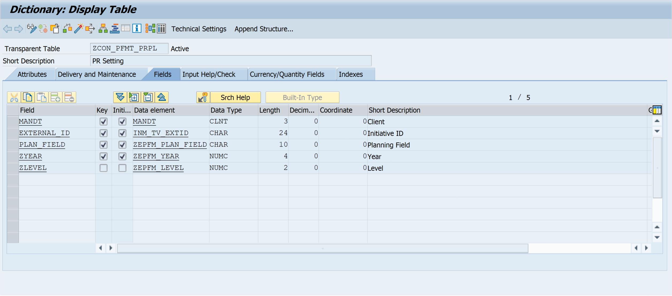

* + The following custom tables are mainly used

|  |  |  |
| --- | --- | --- |
| **Table** | **Short Description** | **Use for** |
| ZCON_PFMT_GROUPT | Target Setting Group Configuration | CDS View : ZCON_PFM_DDL_I_TGRP |

* + ZCON_PFMT_GROUPT – Table

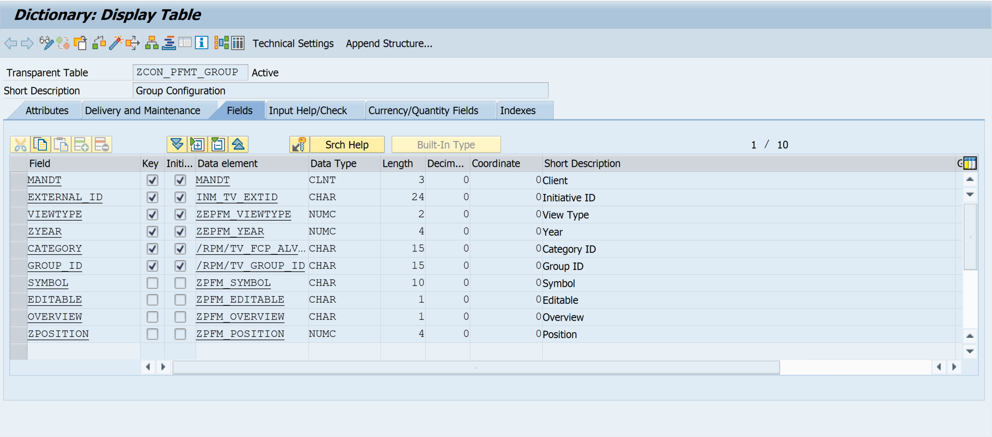

## Odata Service

* Service Name: ZCON_PFM_ODATA_TARGET
* Service Type: OData V2 – UI
* Service URL: /sap/opu/odata/SAP/ZCON_PFM_ODATA_TARGET_SRV

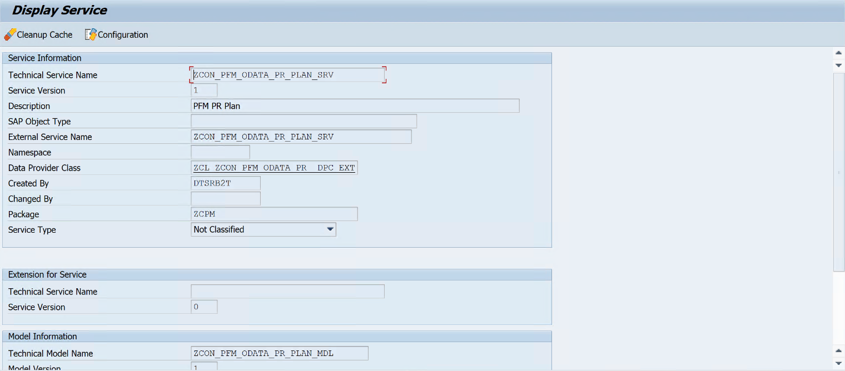

## Entity Sets

* The list of entity sets used is as follows

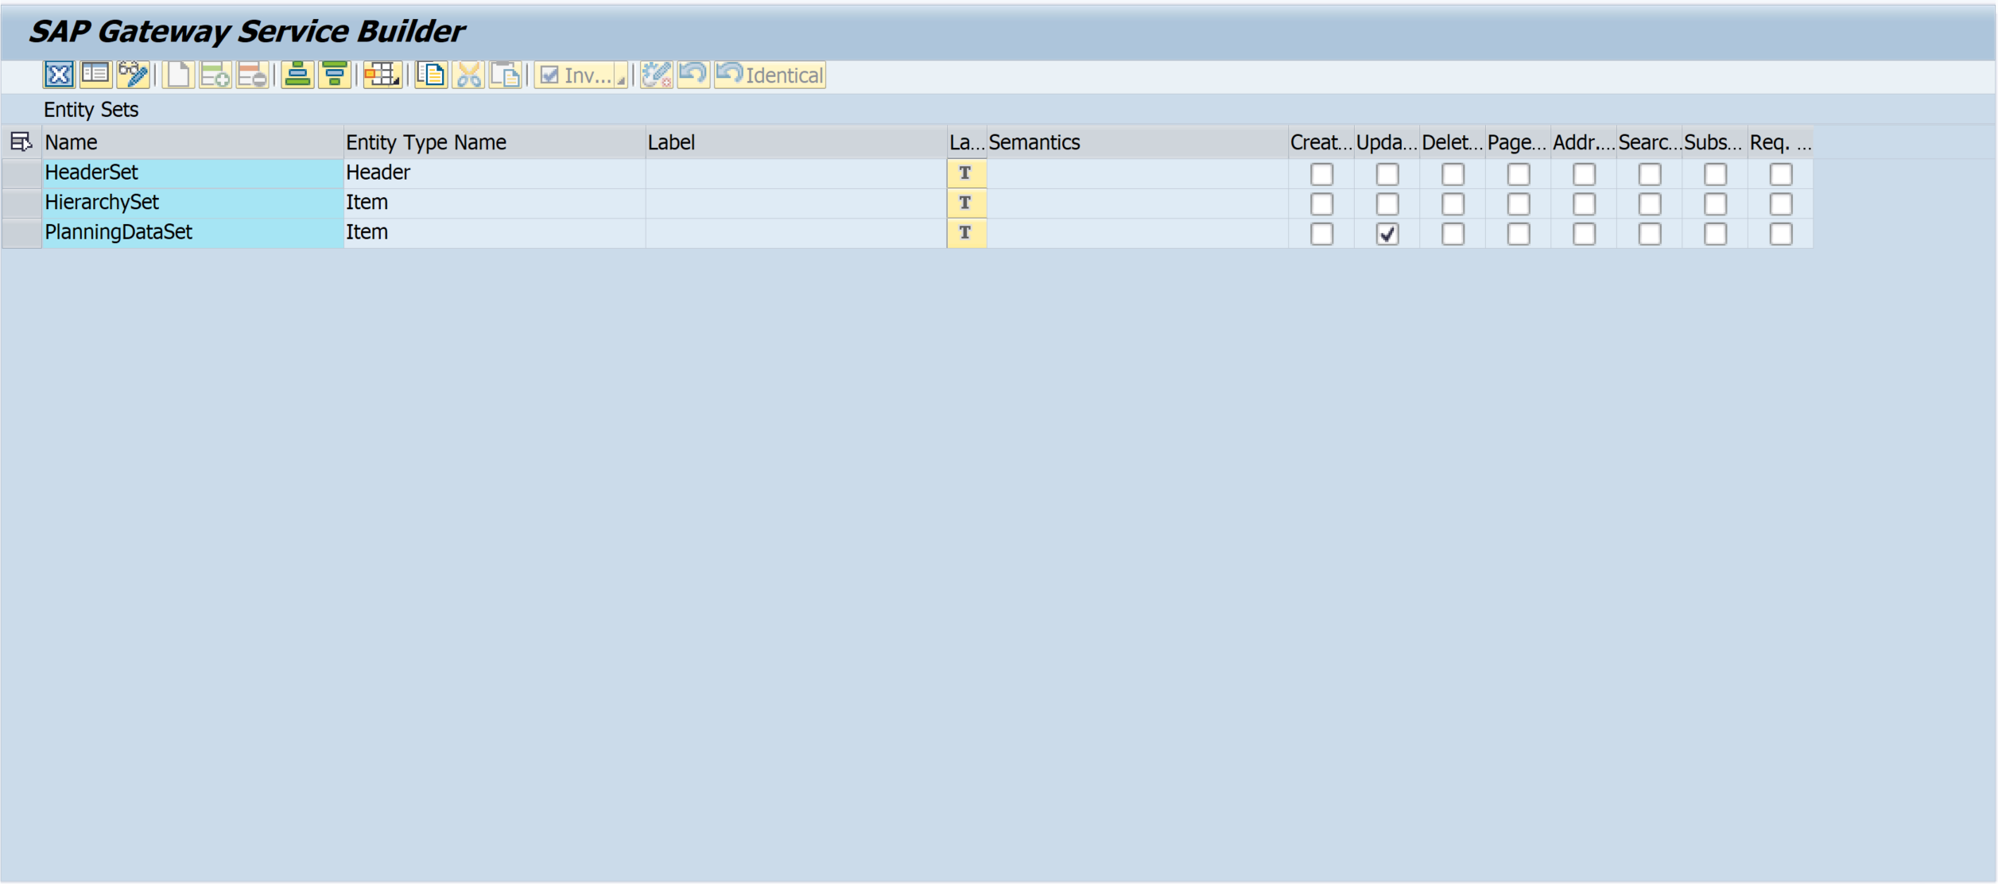

* Entity type - Item the entity type by importing from the DDIC structure ‘ZCON_PFMS_PLAN_ITEM‘

The field ‘Data‘ serializes different structure types based on different Entity Sets

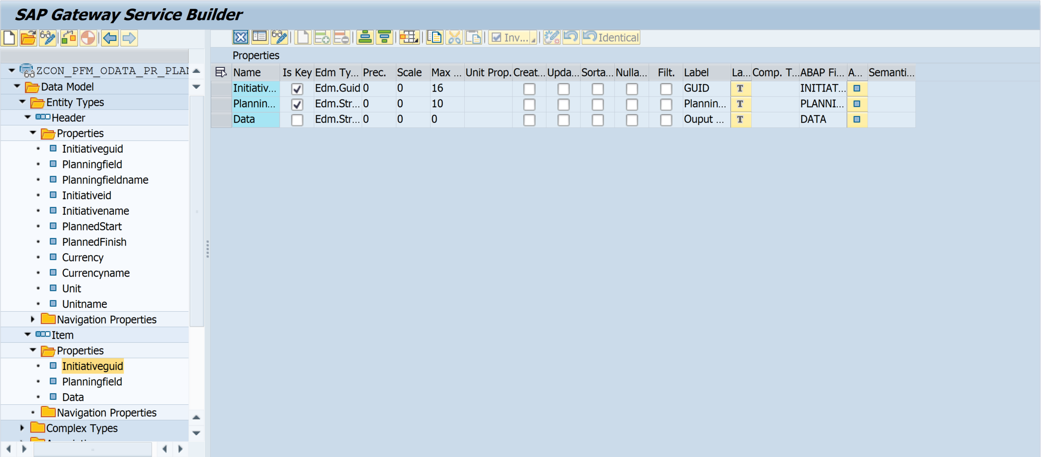

## Function Imports

The list of function imports used is as follows

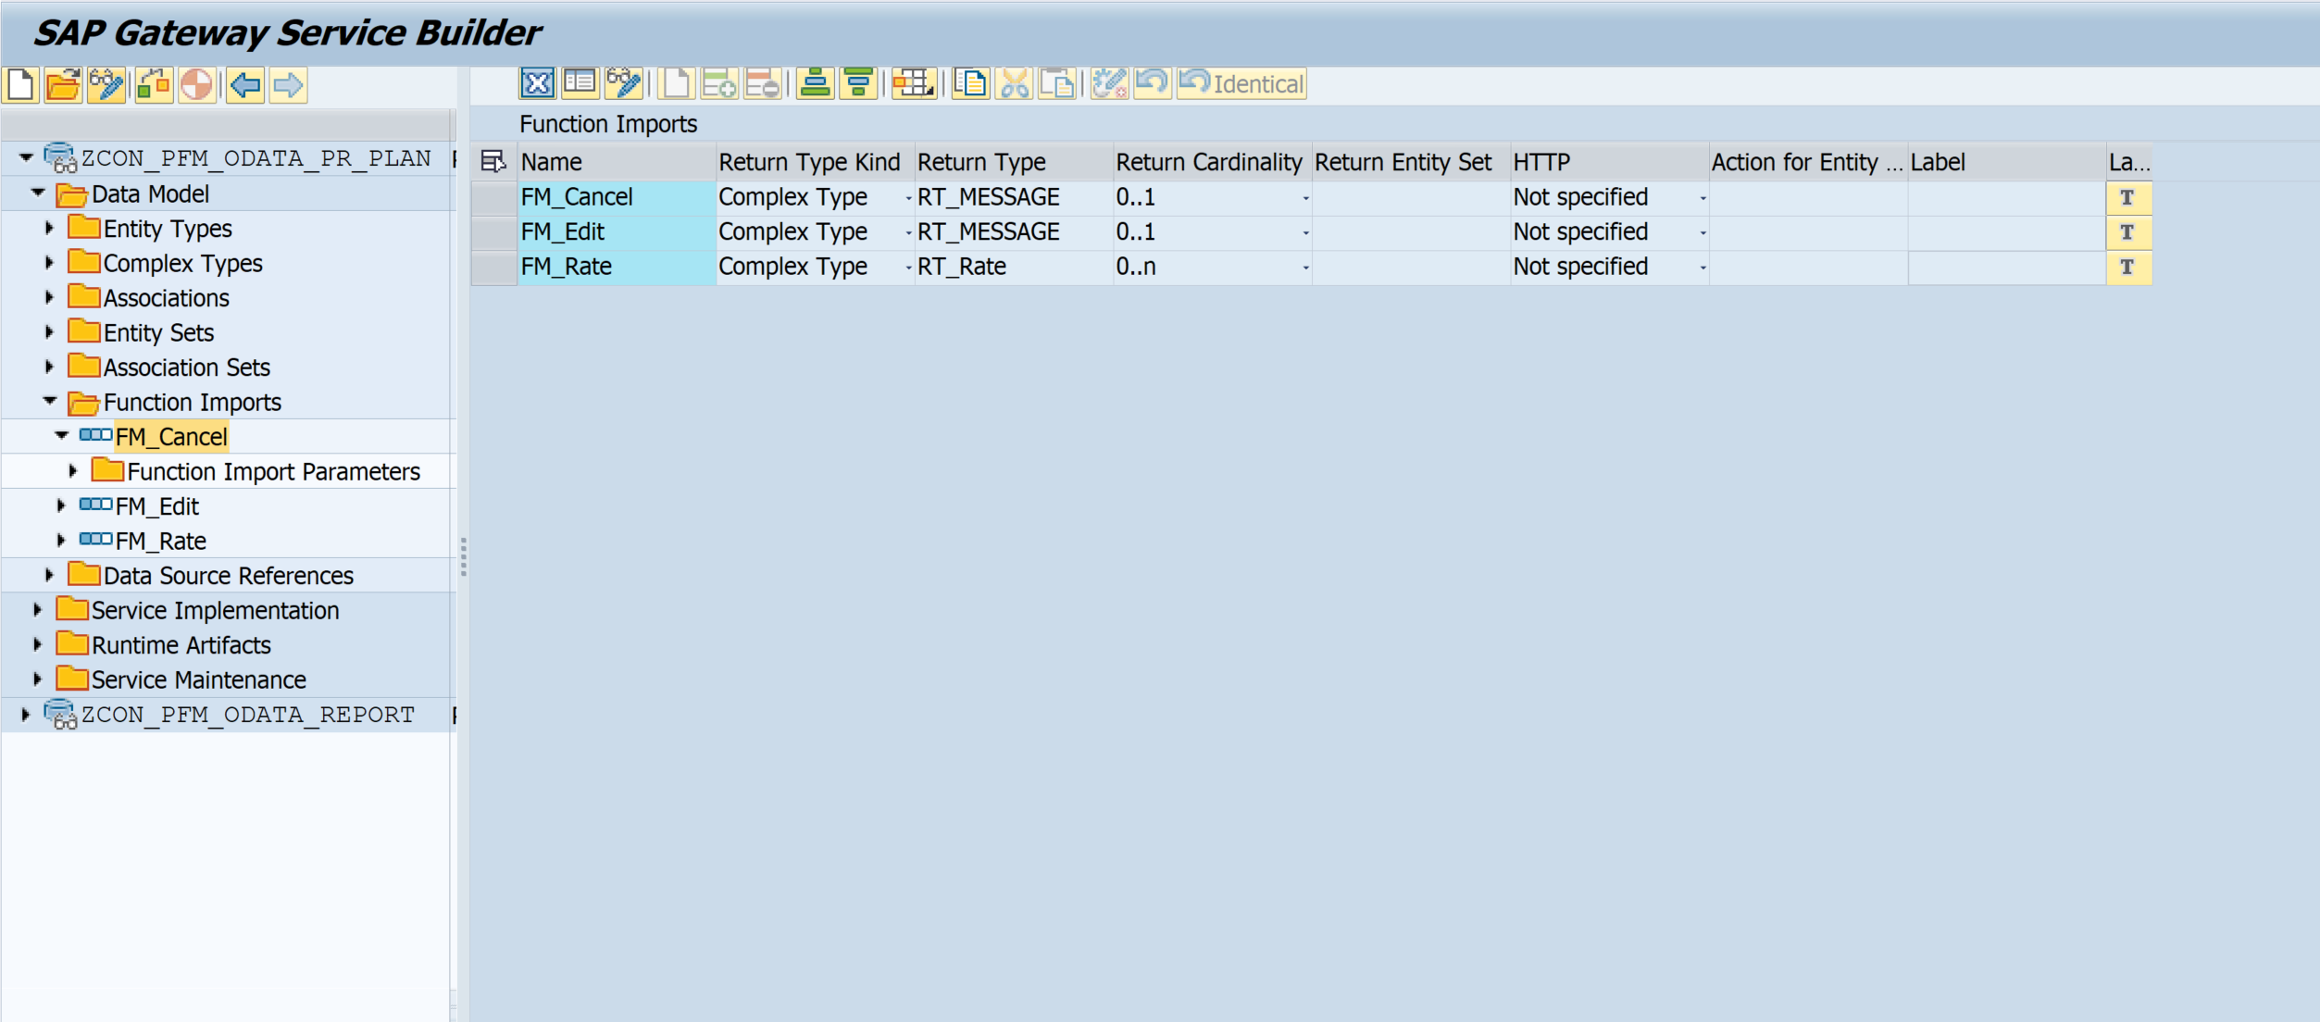

* Definition of Function Imports

|  |  |  |  |
| --- | --- | --- | --- |
| **Name** | **Use for** | **Import Parameters** | **Export Parameters** |
| FM_Cancel | Cancel Button |  |  |
| FM_Edit | Edit Button |  |  |

## Data Provider Class

* Class Name: ZCL_ZCON_PFM_ODATA_TAR_DPC_EXT

Redefine methods:

|  |  |
| --- | --- |
| **Method** | **Use for** |
| EXECUTE_ACTION | Function Imports:  FM_Edit  FM_Cancel |
| HIERARCHYSET_GET_ENTITY | Data Source for Bucket/Item Tree |
| PLANNINGDATASET_GET_ENTITYSET | Data Source for Bucket/Item Planning Data |
| PLANNINGDATASET_UPDATE_ENTITY | Write data to Bucket/Item Planning  Table |

* FM_Edit- EXECUTE_ACTION method

Add an object lock by inputting parameters; if successful, return true, otherwise return an error.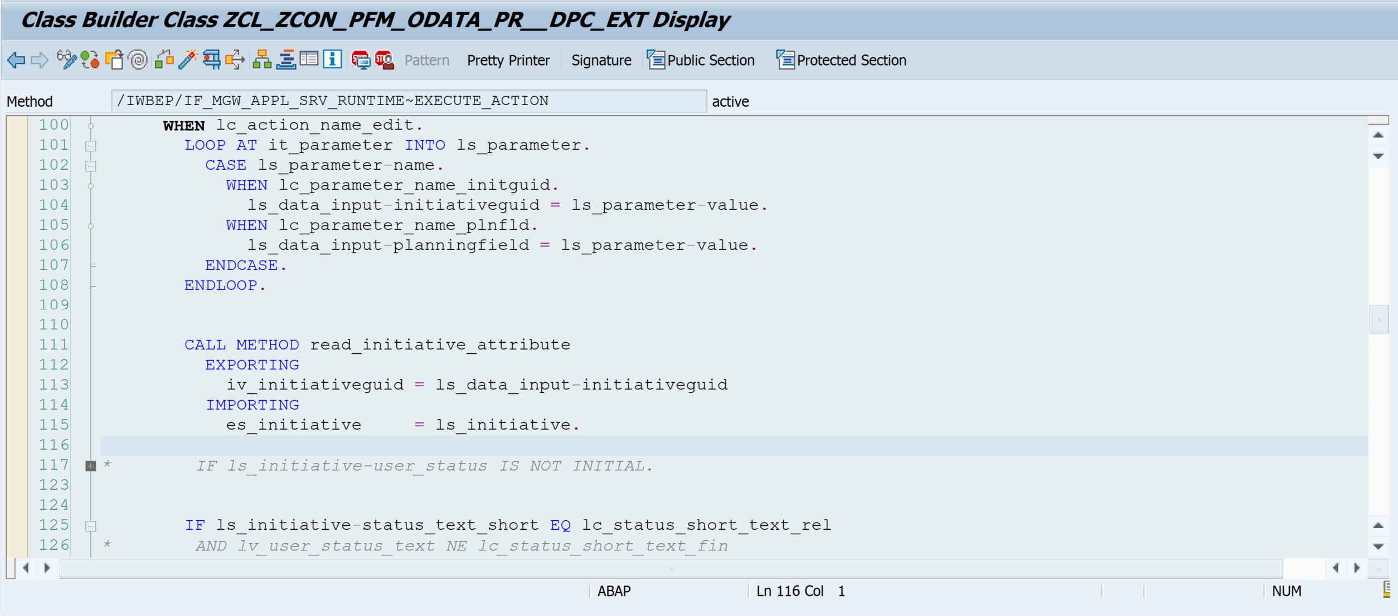

* FM_Cancel- EXECUTE_ACTION method

Get the lock object by the lock parameter,

If the lock owner is the current user, the unlock returns successful, otherwise it fails

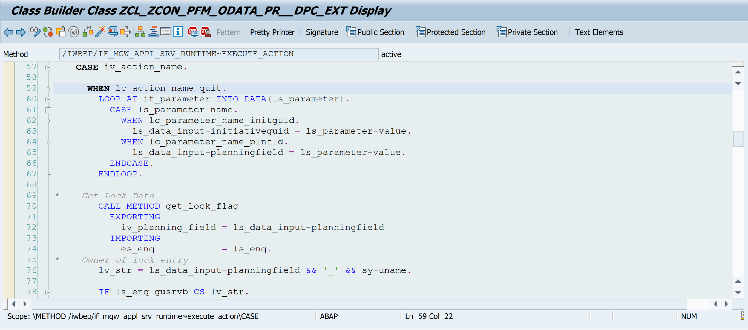

* HIERARCHYSET_GET_ENTITY-method

Display bucket tree:

Step 1, Get Buckets by importing “Bucket GUID”.

Step 2, Get Parent Buckets and Sub Buckets from step 1 Buckets.

Step 3, Filter out “Inactive” Buckets and their Sub Buckets.

Display bottom level items:

Step 1, Get assigned portfolio items by importing “Bucket GUID”.

Step 2, Filter out portfolios items which are not assigned to above buckets.

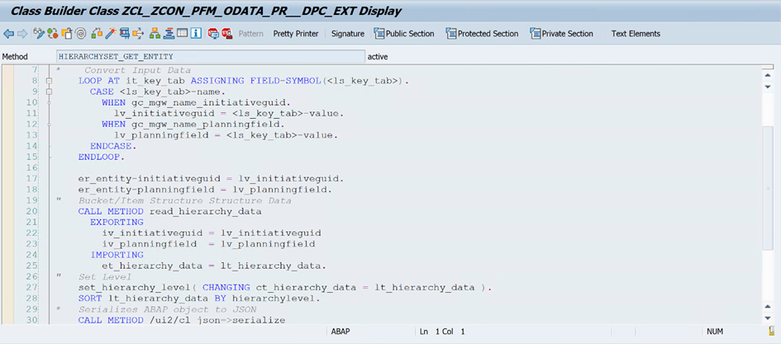

* PLANNINGDATASET_GET_ENTITY-method

Get saved financial planning and capacity planning data on Buckets and Items via the API

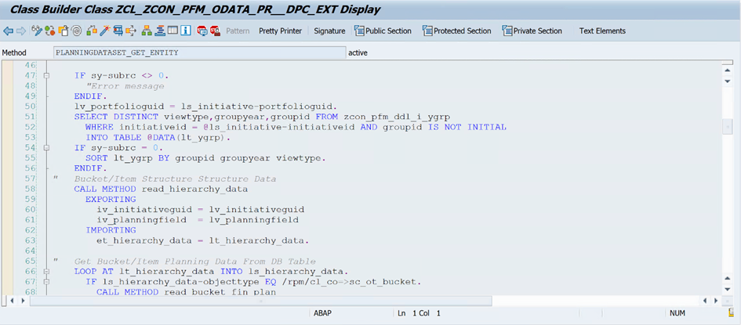

* PLANNINGDATASET_UPDATE_ENTITY-method

Update financial planning on Buckets and Items through the API

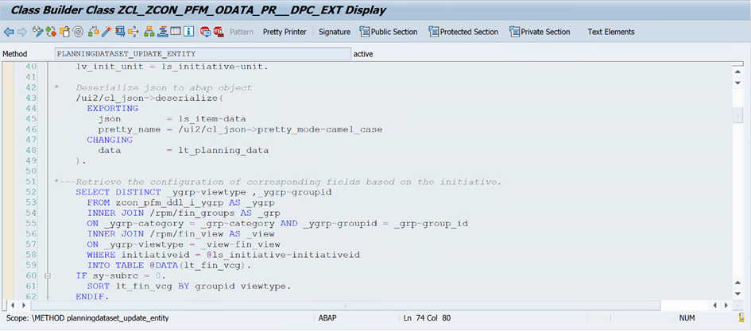

## Other methods

* Class: ZDE_CL_CON_PFM_PLANNING_UTIL

|  |  |
| --- | --- |
| **Method** | **Use for** |
| GET_EXCH_RATE | Read the Exchange Rate Data |
| CONVERSION_TIME_UNIT | Convert to Same Time Units |
| ADD_LINKED_SUB_BUCKET | Remove inactive bucket |
| READ_HIERARCHY_DATA_BY_BUCKETS | Bucket/Item Structure Tree |
| SET_HIERARCHY_LEVEL | Add Level |
| GET_LOCK_BUCKET_FLAG | Get the current lock data |
| LOCK_BUCKET | Add lock for the current plan |
| UNLOCK_BUCKET | Unlock for the current plan |
| UPD_BUCKET_FIN_PLAN | Update Financial Planning for Bucket |
| UPD_FIN_PLAN | Update Financial Planning for Item |
| CHECK_AUTHORIZATION | Authorization Check |

## Other Functions

|  |  |
| --- | --- |
| **Function** | **Use for** |
| ZDE_CON_PFM_FM_FIN_GRPB_MODIFY | Update Financial Planning for Bucket |
| ZDE_CON_PFM_FM_FIN_GRP_MODIFY | Update Financial Planning for Item |

The above function modules reference the following existing system function modules:

/RPM/FIN_GROUP_B_MODIFY

/RPM/FIN_GROUP_MODIFY

## Authorization

* Verify bucket edit permission
* Verify item edit permission

# Other